Project Report

~ Grocery Android App

Using Kotlin Language

* ♦ Introduction

This app is build using Kotlin Language in Android Studio. This project is build with MVVM(Model View ViewModel) for architectural patterns. We have also used Room for Database. And Coroutines and RecyclerView for displaying list of items, which the user will enter. The app is User Friendly as the user can insert grocery items and delete as per their convenience.

* ♦ Project Introduction

This project is build to solve the user issues. As everything cannot be remembered, users frequently forget to buy the things they want to buy. This app can be helpful in such situations for users. As they can note down all the things that should be bought, So they cannot forget them. With the assistance of this app they can make the list of grocery items, so that you don’t forget anything.

* ♦ Technologies Used in this Project
* MVVM(Model View ViewModel) :
* Room Database
* RecyclerView
* Couroutines

♦ flowchart of application

(i) CourInitially when the app gets installed it appears on your all apps list with name "Grocery App".

(ii) When the user first opens app there is no items or things it's empty.

(iii) Then for adding the items there is an button at the right bottom of the app with "+" sign, After clicking on it the user will be able to add items to the list.

(iv) This includes an pop - up window which user have to fill the details like name, quantity, and price/kg.

(v) After adding it the user can see the item at the top of the app with details filled previously and also total amount is calculated.

(vi) Now, if a user wants to delete it so he/she can simply click on the dustbin icon which will be seen in the item list, after clicking it the item will be deleted from the list. Now for adding another the user have to do the same procedure.

♦ Advantages of the application

The application is user friendly and is designed in a less complex way for the user to use it without facing any complications. User can add and delete the grocerry items as per their convenience. It is designed as simple as writing a notepad.

♦ Disadvantages of the application

Though the application has many advantages but it has some disadvantages to, & one of the biggest disadvantage is that when the user will make list then it has to be deleted, for creating new one. As we have to delete the first one there is'nt any backup of the first list as the user wants to see the first list that is not possible.

♦ URL

* Google Developer Profile

<https://g.dev/fahemikhan>

* Github URL

<https://github.com/smartinternz02/SPSGP-67784-Virtual-Internship-Android-Application-Development-Fahemi>

● Demo URL

<https://github.com/smartinternz02/SPSGP-67784-Virtual-Internship-Android-Application-Development-Fahemi/blob/main/Grocery%20App.mp4>

♦ result (output screenshots)

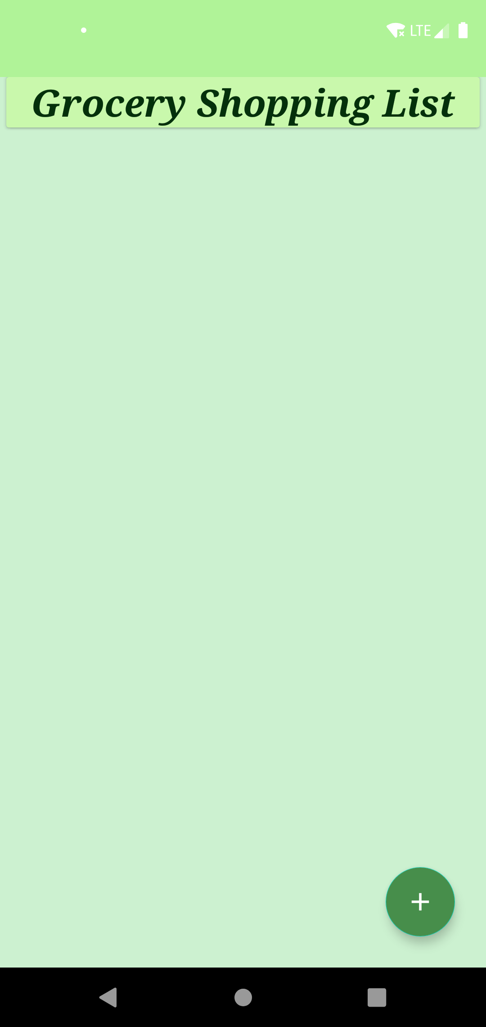 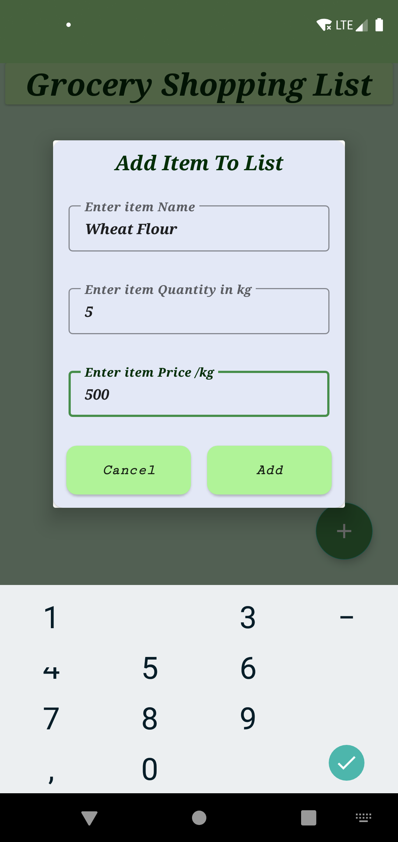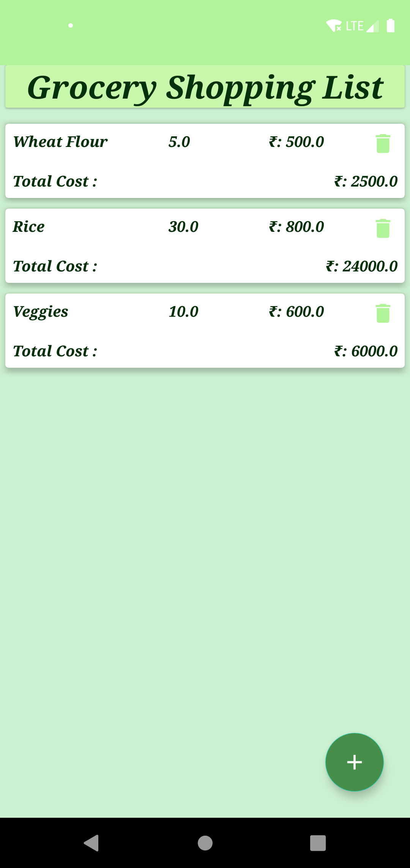

♦ applications

Applications can be included as follows :-

(i) Making grocery items list

(ii) This application is not just for grocery but, user can also include other shopping things.

(iii) User can add, update and delete the things added in lists.

♦ Conclusion

Conclusion :- Created an Grocery App using MVVM and Room Database in Kotlin Language. Using this application, the user will be able to note down grocery items list he/she is willing to purhase. So that they do not miss out anything. This is a user friendly application which is designed to provide user an easy and friendly interface.

♦ Future scope of the application

In future updates of the application we will try to make it more flexible and to overcome the drawbacks of previous releases. As the application can have options for saving different lists at different names. So that the user can use it for other lists purpose also. They can also make schedules for shopping including shopping lists. So that they can save different lists for different things.

♦ Acknowledgement

First I would like to thank SmartInternz, for giving me the opportunity to do an internship. And also would like to thank the mentors for giving us this opportunity to learn new things. I have learned a lot new things, during this internsghip period. Thank you team SmartInternz for guiding us throughout the project session.

♦ Bibliography

* Google Developers

<https://developers.google.com>

* Android Developers  
  <https://developer.android.com>
* Wikipedia

<https://www.wikipedia.org>

♦ Appendix

Source Code of the application

<https://github.com/smartinternz02/SPSGP-67784-Virtual-Internship-Android-Application-Development-Fahemi/blob/main/Grocery-App.zip>

(Provided the github link to the project source Code).